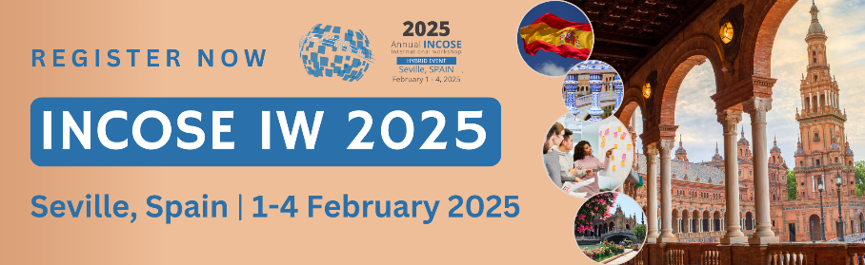

[Your company logo]
[Your program dates]

Hello [insert Manager’s name]

The annual INCOSE International Workshop (IW) is the premier collaborative systems engineering event. Unlike most conferences, there are no paper, panel, or tutorial presentations. Instead, attendees spend four focused days working alongside fellow systems engineers who are there to share their input and knowledge from their domains and plan for future projects.

IW will be held outside of the United States for the first time in 2025 in Seville, Spain. This is a unique chance for European companies to have more convenient representation and for non-European companies to expand their global impact.

Below are just some of the reasons why I should attend:

- I can contribute to the development of new products, presentations, standards, and industry partnerships, directly impacting the future of [insert industry/field].
- For the opportunity to join innovative working sessions, since this is a workshop format and not a traditional conference setting.
- To enhance our reputation as a leader in the field of systems engineering and attract top talent.
- To network and connect with professionals from around the world, building valuable relationships that can benefit [insert company] in the long term.

The approximate cost for me to attend the event will be:
Registration:
Airfare:
Hotel:
Meals:
Other expenses:
Total cost:
You can learn more about INCOSE International Workshop at www.incose.org/iw2025.

Thank you for your time. I look forward to hearing from you.
[signature]
