

[Your company logo]
[Your program dates]
Hello [insert Manager’s name]
The INCOSE International Symposium is the premier international forum where practitioners, researchers, and educators share their insights, experiences, and innovations, furthering the practice of systems engineering. The symposium has occurred every year since 1991 and is the largest annual gathering of the systems engineering community.
Below are just some of the reasons why I should attend the symposium:
- I can learn something new that I can use on the job
I will come prepared with tough questions to ask the speakers and panelists and I plan to take my newfound knowledge back to the office after the symposium.
- I can expand our network among the worldwide systems engineering community
New questions arise every day on the job. Consider how great it could be if I could phone or email a colleague with similar experiences to see how they have addressed the same challenge.
- I can contribute and advance the discipline
I will share my own experience, points of view, approaches and best practices with other participants, and make a contribution towards moving our field forward.
- Hear the latest from sponsors and exhibitors
I will take advantage of a unique opportunity to gain insights into the latest thinking and tool support for systems engineering.
- [optional if you are certified] I can gain Professional Development Units (PDUs)
I can claim one PDU toward my INCOSE Systems Engineering Professional (SEP) certification per hour of session participation.
The approximate cost for me to attend the event will be: Registration:
Airfare:
Hotel:
Meals:
Other expenses:
Total cost:
You can learn more about the INCOSE International Symposium at https://www.incose.org/symp2025.
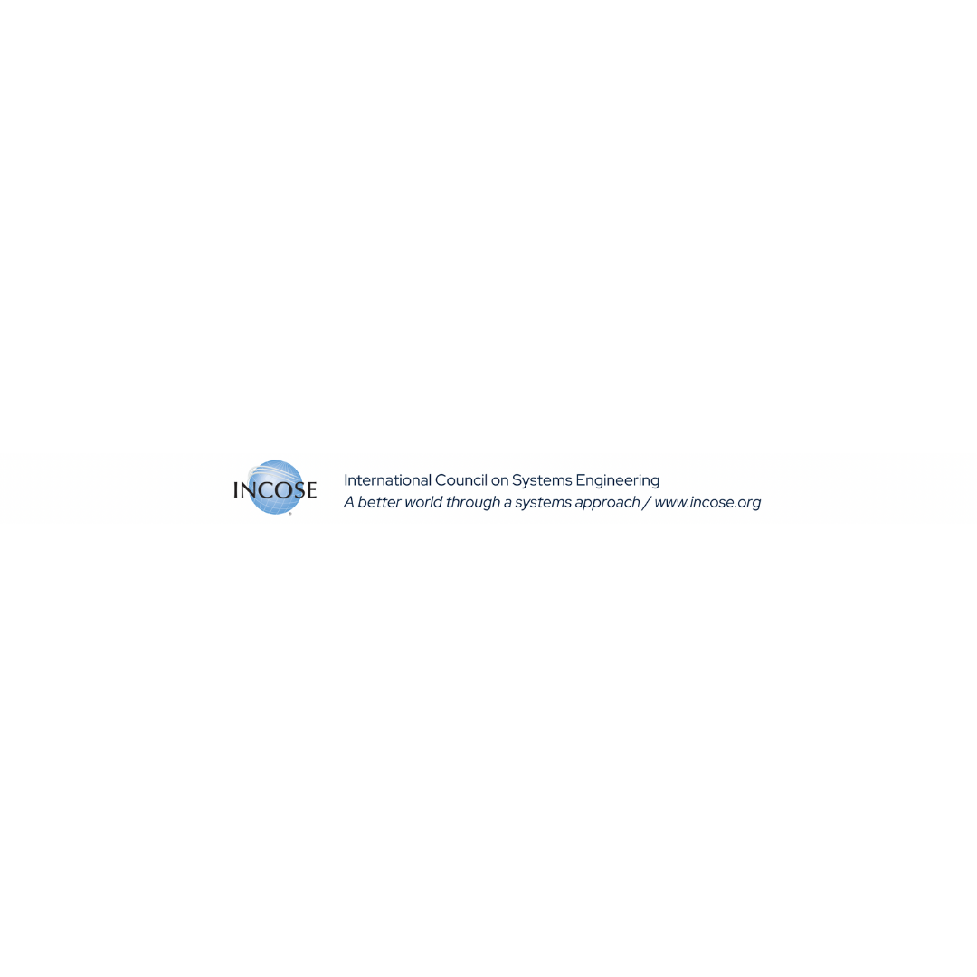
Thank you for your time. I look forward to hearing from you. [signature]

