TUTORIAL ENROLLMENT FORM (Submit to INCOSEEnchantment@comcast.net)

Tutorial on the INCOSE Systems Engineering Handbook V4.0 in Preparation for the SE Certification

(Thursday-Friday, 12-13 May 2016)
Albuquerque, NM

- please fill out and email this registration form to INCOSEEnchantment@comcast.net

Name: ___________________________________________________________________________

Company: ________________________________________________________________________

Day Phone: _________________________ Cell Phone (optional): __________________________

Email: _____________________________ INCOSE Member No. __________________________

Designate the amount paid:

 | INCOSE Member | Non- Member | Student
TUTORIAL: INCOSE SE Handbook V4.0 | $400 | $500 | $0

- Payment Methods:
- Payment by CREDIT CARD: can only be accepted via the link at the INCOSE Enchantment web site: www.incose.org/enchantment - go to the Tutorials page under the Library and Resources home-page tab. Credit card payment will not be available at the door.
- Payment by CHECK: mail your check, payable to “INCOSE Enchantment Chapter,” with a copy of this registration form to:

Spring 2016 Tutorial
INCOSE Enchantment Chapter
P.O. Box 50516

Albuquerque, NM 87181

TO SUMMARIZE: Please (a) submit this form by email (whether paying by check or credit card) and (b) pay on-line or by check. You will receive an email receipt which will act as your confirmation. If you do not receive a confirmation or have trouble paying, please contact Mary Compton at mlcompt@sandia.gov

For any other questions, email Ann Hodges at alhodge@sandia.gov.

To join INCOSE or renew your membership, visit https://www.incose.org/cc_orders/joinINCOSE.cfm INCOSE Enchantment web site: www.incose.org/enchantment
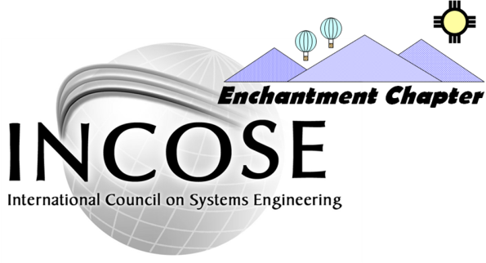
SPRING TUTORIAL

Tutorial on the INCOSE Systems Engineering Handbook V4.0
Led by John Clark
Thursday-Friday, 12-13 May 2016, 8:00 a.m. – 5:00 p.m.
Workforce Training Center, Albuquerque, NM
Brought to you by the INCOSE Enchantment Chapter, Albuquerque NM

Tutorial on the INCOSE Systems Engineering Handbook V4.0
Interested in learning or reviewing SE from the INCOSE SE Handbook V4.0 and ISO/IEC/IEEE 15288:2015 perspective, optionally taking the INCOSE SE Professional (SEP) exam, and achieving INCOSE Associate SEP (ASEP), Certified SEP (CSEP), or Expert SEP (ESEP) Certification? If Engineer or Manager is in your job title, please join us on May 12 and 13, 2016 for this tutorial. This 2-day session will provide a brief overview of the INCOSE SEP process and a detailed summary of each chapter of the INCOSE SE Handbook V4.0. INCOSE member login (including INCOSE Corporate Advisory Board (CAB) employees and students) to access and review the SE Handbook V4.0 in the INCOSE Store and/or to access the INCOSE SE Handbook V4.0 Training Working Group webinar recordings in the INCOSE Library is highly recommended either in advance of or as follow-up to this tutorial.
The INCOSE Enchantment Chapter is presenting this tutorial to help you learn or review SE and optionally prepare for the certification exam. The tutorial covers the certification process and SE Handbook V 4.0. Course materials include the tutorial slides (including PowerPoint Notes), example exam questions, exam tips, help to fill-out your application, reference to audio & video recordings for later downloading, and a certificate of completion.

Learning Objectives:
- Understand the SEP levels, requirements, and application process
- Learn or review SE from the INCOSE SE Handbook V4.0 and ISO/IEC/IEEE 15288:2015 perspective
- Summarize the SE Handbook V4.0 chapters
- Take a 120-question example exam

Topics:
- SEP Certification
- SE Handbook V4.0 Scope, Overview, Life Cycle Stages, Processes, Tailoring, Application, Cross-Cutting Methods, and Specialty Engineering
The course is aimed at:
- Engineers of all Disciplines
- Managers
- Leaders and decision makers

THE PRESENTER
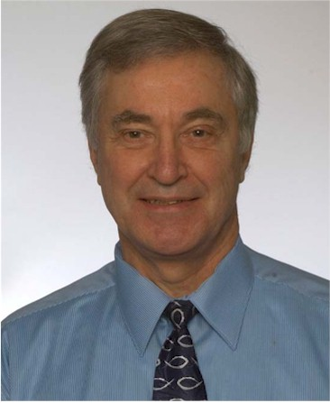  John O. Clark is a retired Chief Engineer and Corporate Systems Engineering (SE) Instructor at Northrop Grumman Corporation (NGC) with several years of experience applying SE and Software Engineering. He is an internationally recognized speaker and Subject Matter Expert in SE, an SE tutorials instructor in major SE symposia and webinars, and a founder and member of several NGC and INCOSE Working Groups (WGs). | For NGC, John was the founder of the SE Handbook WG, the Agile Community of Practice (CoP), and the INCOSE CoP; a key member of the Process WG, Training WG, and Requirements WG; the SE Associates (SEA) SE instructor; and the lead SE developer of the NGC SE Handbook and SE101 course. For INCOSE, he is the Training WG founder and chair, Process Improvement WG chair, SE Handbook Tutorial project leader and instructor, SE Fundamentals Tutorial developer and instructor, a Certified SE Professional (CSEP), and the Director of Education and Training of the INCOSE Hampton Roads Area Chapter. Recipient of the NGC Exemplary Performance Award for Multi-Sector Collaboration from Wes Bush (NGC President and CEO) and Dr John Chino (NGC VP of Programs and Engineering) for developing the NGC SE Handbook. Recipient of the coveted INCOSE Outstanding Service Award and selected to the INCOSE Hall of Leaders at the INCOSE International Symposium in 2010 “For promoting the INCOSE Certification program through leadership in the development and ongoing delivery of the INCOSE SE Handbook Tutorial.” Recipient of the INCOSE Technical Operations Collaboration Award at the INCOSE International Workshop in 2014 “For the development, delivery, and management of the portfolio of INCOSE webinars, tutorials, and presentations in collaboration with Chapters and other Working Groups.” John is a member of the Institute of Electrical and Electronics Engineers (IEEE) 1220 WG; a member of the Society of Automotive Engineers G-47 SE Committee developing EIA-632A; the lead of the G-33/G-47 Technical Reviews and Audits WG; a representative to the U.S. Technical Advisory Group (TAG) to the International Organization for Standardization (ISO); and a member of the author/review teams for ISO/IEC/IEEE 15288, 12207, TR 19760, TR 24748, and the INCOSE SE Handbook. BSEE Penn State, MSEE State University of New York, SE Advisory Council member at the University of Maryland, and adjunct SE instructor at the California Institute of Technology (CalTech), University of Maryland, and Old Dominion University.

MEETING DETAILS
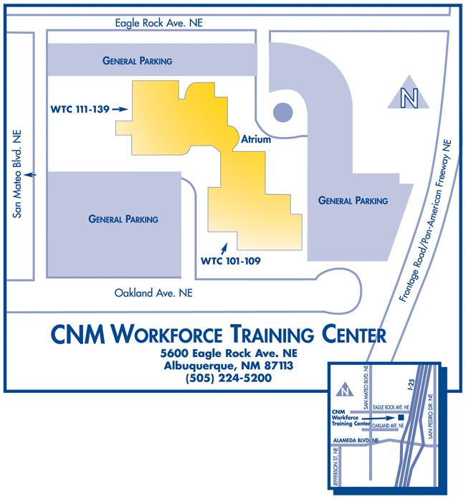
Time: Registration is 7:30 – 8:00 a.m.;
Tutorial is 8:00 a.m. – 5:00 p.m.
Date: Thursday-Friday, May 12-13, 2016
Place: Room 137, Workforce Training Center (WTC), 5600 Eagle Rock Ave. NE Albuquerque, NM 87113, http://www.cnm.edu/depts/wtc/index.html.
Directions: From Junction of I-40 and I-25 in Albuquerque take I-25 North to exit 233, Alameda Boulevard. Take a left and cross the freeway. See map to left.
Package: The tutorial cost includes tutorial notes, lunch and snacks.
Payment: Please (a) submit the attached form by email (b) pay by check or on-line (see Tutorials under Library tab at www.incose.org/enchantment). You will receive an email receipt, which will act as your confirmation. If you do not receive a confirmation or have trouble paying, contact Mary Compton at mlcompt@sandia.gov.
Contact: Other questions? Contact Ann Hodges at alhodge@sandia.gov.

