# **2025 Slate for INCOSE Enchantment Chapter Leadership**

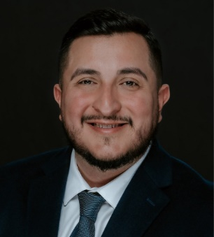

### **Past-President: Jose Parga (not electable position)**

([jose.parga@incose.net](mailto:jose.parga@incose.net)) Dr. Jose Parga is a Research and Development Engineer focusing on Advanced Systems Development at Los Alamos National Laboratory. He has a Ph.D., M.S., and B.S. in Mechanical Engineering with a focus in Nuclear Engineering from The University of Texas at Austin. Dr. Parga has experience in Requirements Engineering, Decision Analysis, Systems Integration, Verification and Validation, and System Operation. Dr. Parga has previous experience working at production agencies while at LANL and Kansas City National Security Campus – New Mexico Operations. He is currently working on integrating Model Based Systems Engineering for future systems safety and hazard analysis at LANL.

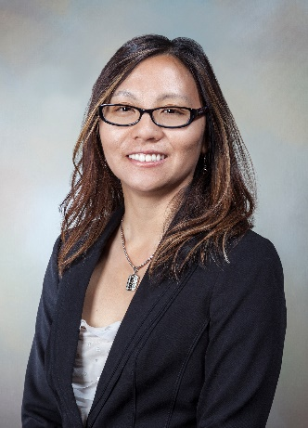**President: Amy Moy (not electable position)**

Amy graduated with a B.S. in Chemical Engineering from Cornell University and an M.S. in Chemical Engineering from the University of New Mexico. She is a certified Lean Six Sigma Master Black Belt, senior causal analyst, and Project Management Professional. She has over 27 years of management and engineering experience. She has held positions in research and development, design and production, and program and project management. Amy has experience as a project, product, process, and quality engineer in chemical manufacturing, and microelectronic design and production. She was also an R&D engineering manager and currently an R&D systems engineer at Sandia National Laboratories. She is also the INCOSE CAB representative for Sandia.

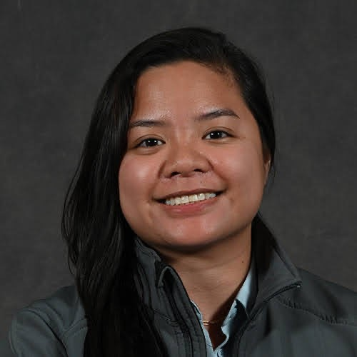**Vice President: Jen Giang**

Jen Giang currently serves as a Systems Engineering Integration and Test Lead at Sierra Space Corporation where she leads an interdisciplinary team through major program milestones and guidance systems engineering tasking to success. Jen is also pursuing a Ph.D. in Systems Engineering through Colorado State University with a dissertation focus on “Risk Assessment Framework for Mitigating Data Reconstruction in GAI Applied to Complex Mission Concepts”. Additionally, Jen is part of the INCOSE Technical Leadership Institute, a two-year international program addressing global systems engineering challenges. Jen is a well-rounded systems engineer with experience in research and development, requirements and verification, integration and test, and Model Based Systems Engineering through professional experience, education, and prior military service.

Why would I like to be on the Board for the Enchantment Chapter?

I am a passionate advocate for Systems Engineering and the advancement of STEM. I am deeply committed to fostering a community of collaboration, innovation, and inclusivity. Serving on the board for the Enchantment Chapter would provide me with a unique opportunity to be the positive influence I want to be, support INCOSE’s mission, enhance my leadership skills, and expand my professional network. I am highly motivated to make a meaningful impact in the industry and to support the growing Systems Engineering community.

### **Secretary: Ann Hodges**

([ann.hodges@incose.net](mailto:ann.hodges@incose.net)) Ann Hodges retired in Spring 2023 after 48 years of service at Sandia National Laboratories and was a Distinguished Member of Technical Staff. She was the Mission Services Division’s systems engineering lead for the systems engineering part of the Project and Product Delivery System (PPDS) at Sandia National Laboratories and was a project manager and systems engineer for a complex exploratory-phase project. She is a primary author of the risk-informed graded approach to the application of project management, systems engineering and quality management which is one of the key aspects of the PPDS. She obtained a BBA and an MS in Computer Science from the University of NM, and holds CSEP, SAFe SPC4, and CMII certifications. Leadership positions that Ann has held in the Enchantment Chapter include Director-at-Large 2011-2012, President-Elect and acting Secretary 2013, President 2014-2015, and Secretary 2015-present. She is the Chair of the INCOSE Systems Engineering for Early Stage R&D working group.

### **Treasurer: Mary Compton**

([mary.compton@incose.net](mailto:mary.compton@incose.net)) Mary Compton retired from Sandia National Laboratories (SNL) in 2022 after a rewarding career starting in 1990. She has a BS in Biology, a Masters in Library Science, and a Master of Education in Science Education. She completed a Master of Science in Software Engineering with a specialization in Software Systems Engineering in 2010. Mary was a librarian for 20 years, including over 10 years in the Technical Library at SNL. From 2001 until 2018 Mary was a requirements engineer in support the nuclear deterrence mission for information systems and nuclear weapons systems and subsystems. She transferred to the Model Based Systems Engineering (MBSE) department in 2018 where she performed MBSE for nuclear weapon development programs during the last four years of her career at SNL. Mary served as the Enchantment Chapter Secretary 2008-2011 and has been Chapter Treasurer since 2012.

# **Directors at Large**

### **Cheryl Bolstad**

### ([cheryl.bolstad@incose.net](mailto:cheryl.bolstad@incose.net)) Dr. Cheryl Bolstad is a Principal Systems Research and Analysis Engineer for the Human Factors department at Sandia National Laboratories in Albuquerque, NM. Dr. Bolstad is a Fellow of the Human Factors and Ergonomics Society and Certified Professional Ergonomist. She has a Ph.D. in Psychology specializing in cognition and human factors from North Carolina State University. Dr. Bolstad has over 30 years of experience working with the Department of Defense and within the commercial sector. She has worked extensively in situation awareness (SA) research, human automation integration, user interface design, team training and performance. Currently Dr. Bolstad is on the board of directors for a regional chapter of INCOSE, the International Society of System Engineers, and on the Technical Program Committee for the Human Factors and Ergonomics Society.

### **Gregory Chavez**

([gregory.chavez@incose.net](mailto:gregory.chavez@incose.net)) Gregory Chavez has direct experience in many facets within systems engineering which include his role as : system product realization team leader, requirements project manager, systems engineer, test engineer, and risk engineer for decisions applications. Gregory was recently the deputy program manager for one of the systems going through a life extension program. Currently, he is the system architecture lead for a project using Agile process technologies and model based systems engineering to fast track a particular system design into production. He has a PhD in Engineering, an MS in structural engineering, a BS in civil engineering, is a licensed professional engineer in New Mexico and working on a certification in systems engineering.

### **Quinn Fatherley**

has been a Senior System Engineer at Lawrence Livermore National Laboratory since 2018. Role is lead lifecycle planner for operational testing and system maintenance. Collateral duties include system interface analysis, functional decomposition, requirements derivation, plus validation and verification tracing and documentation. Previously he served at Los Alamos National Laboratory for 16 years as system requirements architect and system operational testing and maintenance planner. Quinn holds a BSME from UNM, a BA in English and History from UConn, and served on US Navy fast-attack submarines following completion of the Naval Nuclear Propulsion Program. Quinn is a member of the INCOSE Requirements Working Group, and contributor on the INCOSE Guide to Verification and Validation 2021 Revision project.



[This Photo](http://commons.wikimedia.org/wiki/File:Human_outline.svg) by Unknown Author is licensed under [CC BY-SA](https://creativecommons.org/licenses/by-sa/3.0/)

### **This could be you!**

We have an opening for a Director-at-Large. This is an opportunity to work with other systems engineers to serve the regional systems engineering community of practice.

# **UTEP Student Division Advisor**

**(not electable position)**

### **Sergio Luna**

([salunafong@utep.edu](mailto:salunafong@utep.edu)) Sergio Luna is an assistant professor and the graduate program director for systems engineering in the Industrial, Manufacturing, and Systems Engineering department at The University of Texas at El Paso (UTEP). Sergio holds a Ph.D. in Systems Engineering from Stevens Institute of Technology in Hoboken, and a MS in Systems Engineering, and a BS in Mechanical Engineering from UTEP. Sergio’s research aims to support enterprises when transitioning into digital engineering. His work focuses on enabling the interoperability of digital replicas of modular open systems, data-driven decision-making, and human capital development. Throughout his professional experience, Dr. Luna has served as an E-commerce Data Scientist in the consumer product goods domain, a research assistant at the Systems Engineering Research Center (SERC), a Department of Defense affiliated research center, and as asset management intern at the Metropolitan Transportation Authority (MTA) in New York City. Sergio is a member of the International Council on Systems Engineering (INCOSE), the Institute of Electrical and Electronics Engineers (IEEE), and the American Institute of Aeronautics and Astronautics.

# **Texas Tech Student Division Advisor**

**(not electable position)**

### **Richard Burgess**

([Richard.burgess@ttu.edu](mailto:Richard.burgess@ttu.edu)) Richard Burgess is a Lecturer in the Whitacre College of Engineering at Texas Tech University. He teaches ethics courses for undergraduate students, provides guest lectures, and collaborates with faculty and staff regarding ethics in engineering practice and beyond. Additionally, he has worked with professional engineers across the country and has led workshops on engineering ethics for various companies in industry, professional organizations, and institutions. Richard has also taught engineering economics, systems thinking, and is developing a graduate course in systems theory. Richard holds a Ph.D. in Systems and Engineering Management from Texas Tech University. He also holds a B.S. and M.A. in Philosophy (Utah State University and Texas Tech University respectively). His research is focused on the resilience of water resource systems in arid and semi-arid environments. Other research foci include environmental sustainability and the application of systems thinking to ethical analyses. Richard is a member of the International Council on Systems Engineering (INCOSE), the American Society for Engineering Management (ASEM), and the Institute of Industrial and Systems Engineers (IISE).